SJB INSTITUTE OF TECHNOLOGY


No.67, B G S Health and Education city, Dr.Vishnuvardhan road Kengeri, Bengaluru-560060.

DBMS Mini Project Report On
“Healthcare Management System”
In the partial fulfillment of the requirement for 5th Semester
BACHELOR OF ENGINEERING
IN
Information Science and Engineering
BY
MOHAN.K(1JB23IS095)

UNDER THE GUIDANCE OF
Dr. Siddanna S.R
Associate Professor
Department of ISE
SJBIT, Bengaluru


DEPARTMENT OF INFORMATION SCIENCE AND ENGINEERING 2025-2026

|| Jai Sri Gurudev ||
Sri Adichunchanagiri Shikshana Trust ®

SJB INSTITUTE OF TECHNOLOGY
An Autonomous institute under VTU
No.67, BGS Health & Education City, Dr.Vishnuvardhan road, Kengeri, Bengaluru-560060.

DEPARTMENT OF INFORMATION SCIENCE AND ENGINEERING


CERTIFICATE
This is Certify that the DBMS mini project entitled “Healthcare Management System” carried out by MOHAN.K (1JB23IS095), are Bonafide students of SJB Institute of Technology in the partial fulfillment of the requirement for 5th Semester of “BACHELOR OF ENGINEERING” in INFORMATION SCIENCE AND ENGINEERING , during the academic year 2025-2026. It is certified that all corrections/suggestions indicated for internal assessment have been incorporated in the report. The Mini project report has been approved as it satisfies the academic requirements in respect of 23ISI503 prescribed for the 5th semester B.E.

Signature of Guide Dr. Siddanna S R Associate Professor Dept. of ISE SJBIT
Signature of Guide
Dr. Chandrashekar D K Associate Professor Dept. of CSE(DS), SJBIT
Signature of HOD Dr.GOPALAKRISHNA Professor and Head Dept. of ISE SJBIT





ACKNOWLEDGEMENT

We would like to express our profound gratefulness to His Divine Soul Jagadguru Padma Bhushan Sri Sri Sri Dr. Balagangadharanatha Maha Swamiji and His Holiness Jagadguru Sri Sri Sri Dr. Nirmalanandanatha Maha Swamiji for providing us an opportunity to complete our academics in this esteemed Institution.
We would like to express our profound thanks to Revered Sri Sri Dr. Prakashnath Swamiji, Managing Director, SJB Institute of Technology, for his continuous support in providing amenities to carry out this project work in this admired institution.
We express our gratitude to Dr. Puttaraju, Academic Director, SJB Institute of Technology, for providing us excellent facilities and academic ambience, which have helped us in the satisfactory completion of this project work
We express our gratitude to Dr. K V Mahendra Prashanth, Principal, SJB Institute of Technology, for providing us excellent facilities and academic ambience, which have helped us in the satisfactory completion of this project work
We extend our sincere thanks to Dr. Babu N V, Academic Dean, SJB Institute of Technology for providing us constant support throughout the period of Mini Project.
We extend our sincere thanks to Dr. GOPALA KRISHNA M.T, Professor and Head, Department of Information Science and Engineering, SJB Institute of Technology, for providing us valuable support throughout the project work.
We express our deepest gratitude and sincere thanks to our Guide Dr. SIDDANNA S.R, Associate Professor, Department of Information Science and Engineering, SJB Institute of Technology, Bengaluru, for his valuable guidance, support and cheerful encouragement during the entire period of the project work.
Finally, we take this opportunity to extend our earnest gratitude and respect to our parents, the teaching & non-teaching staff of the department, the library staff and all our friends, who have directly or indirectly supported us during the project work.
Regards,
MOHAN.K (1JB23IS095)

Table of Contents

Sl. No. | Chapters | Page No.
 | Acknowledgement | i
 | Abstract | ii
 | Table of Contents | iii
1 | Introduction 1.1….  1.2…Literature Survey | 6  7-8
2 | Software Requirements Specification | 9-10
3 | System Design | 11-12
4 | Implementation | 13-17
5 | Snapshots | 18-1
6 | Conclusion and Future Enhancements | 21
 | References | 22

Abstract

The Health Care Management System is a database-driven application designed to simplify and automate hospital operations. It efficiently manages patient details, doctor information, appointments, and medical records in a centralized system. The main objective of this project is to ensure quick access to patient history and provide an organized way to handle hospital data.
The system stores patient information such as name, age, gender, and contact details along with doctor specialization and appointment schedules. It allows users to add, update, view, and delete records using simple CRUD operations. Relationships between entities are maintained using primary and foreign keys to ensure data integrity.
A cursor-based stored procedure is implemented to monitor overdue appointments automatically, while triggers log all new medical record insertions for better tracking. The system reduces manual effort and errors associated with traditional record-keeping methods.
Developed using MySQL, this project demonstrates effective use of database concepts such as normalization, relational integrity, and automation through triggers and procedures. Overall, it enhances hospital management efficiency, improves accuracy in patient data handling, and provides a reliable framework for future system expansion.

Chapter 1

Introduction
  - Overview of the project

The Health Care Management System is a web-based application designed to manage and streamline healthcare data digitally. It allows users to maintain complete records of patients, doctors, and appointments in a structured manner. The system provides easy-to-use interfaces for adding, viewing, and deleting records.
The project follows a three-tier architecture —
- Frontend: Built using HTML, CSS, and JavaScript, providing a simple and interactive user interface.
- Backend: Developed using Node.js and Express.js, it handles business logic and communicates between the frontend and database.
- Database: Managed using MySQL, where all patient, doctor, and appointment details are securely stored.
1.2 Objectives

- To automate healthcare data management — Replace manual record-keeping with a digital system that ensures faster and more accurate data handling.
- To maintain patient information efficiently — Store and retrieve patient details such as name, age, gender, and contact in a structured format.
- To manage doctor details — Keep track of doctors’ specializations and availability for better appointment scheduling.
- To streamline appointment booking — Enable easy scheduling, updating, and cancellation of appointments between patients and doctors.
- To ensure data consistency and integrity — Use database relationships, triggers, and stored procedures to maintain accurate and consistent records.
- To provide user-friendly interaction — Design a simple frontend interface that allows users to perform CRUD operations easily.
- To demonstrate DBMS integration with real-world applications — Show how MySQL databases can interact with web technologies for complete system functionality.
CHAPTER 2
Literature Survey
Healthcare Information Systems (HIS) and Electronic Health Records (EHR) have become essential for storing, managing, and analyzing patient data. Modern research emphasizes the integration of robust database systems that ensure data accuracy, security, and interoperability. A well-designed healthcare database enables efficient management of patients, doctors, appointments, and medical records while supporting clinical decision-making and hospital workflows.
Data Modeling and Schema Design:
Relational database systems are widely used in healthcare because they maintain referential integrity and follow ACID properties. Studies indicate that normalized schemas improve data consistency and scalability in systems dealing with sensitive medical information. In recent years, hybrid models that integrate JSON or NoSQL structures have emerged to store unstructured data such as doctor’s notes, prescriptions, and test results.
Integrity-and-Auditing:
Maintaining accuracy in medical records is vital. Research supports the use of foreign keys, constraints, and triggers to prevent anomalies. Audit logging mechanisms help track every modification for legal and clinical accountability. Triggers, as used in this project, automatically record insertions and updates to maintain data provenance and transparency.
Workflow-Automation-and-Cursors:
Stored procedures and cursors automate tasks such as appointment reminders and overdue notifications. While cursors enable record-by-record processing, most studies recommend set-based SQL operations for better efficiency and scalability in large hospital databases.
Interoperability and Standards:
To ensure smooth communication among healthcare systems, HL7 and FHIR standards are commonly implemented. These standards define how patient, appointment, and diagnostic data are exchanged across systems, making healthcare services more connected and reliable.
Privacy, Security, and Compliance:
Protecting patient confidentiality is a key concern. Research highlights the need for encryption, role-based access control (RBAC), and anonymization to comply with privacy laws such as

HIPAA and GDPR. Audit trails further enhance security by providing detailed histories of system activities.
Performance-and-Scalability:
As healthcare data volumes expand, performance optimization becomes crucial. Techniques like database partitioning, indexing, and separating OLTP (transactional) from OLAP (analytical) workloads are recommended to handle growing datasets efficiently.
Conclusion:
Literature consistently supports the development of secure, consistent, and scalable database systems for healthcare applications. The proposed database system aligns with these principles by integrating CRUD operations, triggers for auditing, and stored procedures for automation—making it an effective model for managing patient information and hospital operations.

CHAPTER 3
SYSTEM REQUIREMENTS

Functional Requirements
- These define what the Health Care Management System should be able to do functionally:
- Patient Management – The system should allow adding, viewing, updating, and deleting patient details.
- Doctor Management – The system should enable storing and managing doctor information including specialization and contact.
- Appointment Scheduling – Users should be able to create, view, and cancel appointments between patients and doctors.
- Database Integration – All data should be stored and retrieved from a MySQL database.
- Trigger and Procedure Execution – The system should automatically log actions and execute stored procedures for overdue appointments.
- Error Handling – The system should handle invalid inputs or failed connections gracefully.
- User Interface Interaction – The frontend should allow users to perform CRUD operations easily via buttons and forms.
- Data Validation – Ensure required fields are filled and formatted correctly before submission.

Software Requirements
- These specify the software tools and technologies required to develop and run the project:
- Operating System: Windows / Linux
- Backend Environment: Node.js (Express.js Framework)
- Frontend Technologies: HTML, CSS, JavaScript
- Database: MySQL (using MySQL Workbench or XAMPP)
- Development Tools:

- Visual Studio Code (for coding)
- Postman (for API testing)
- npm (for dependency management)
- dotenv (for environment variables)

- Web Browser: Google Chrome / Microsoft Edge
2.3 ER DIAGRAM

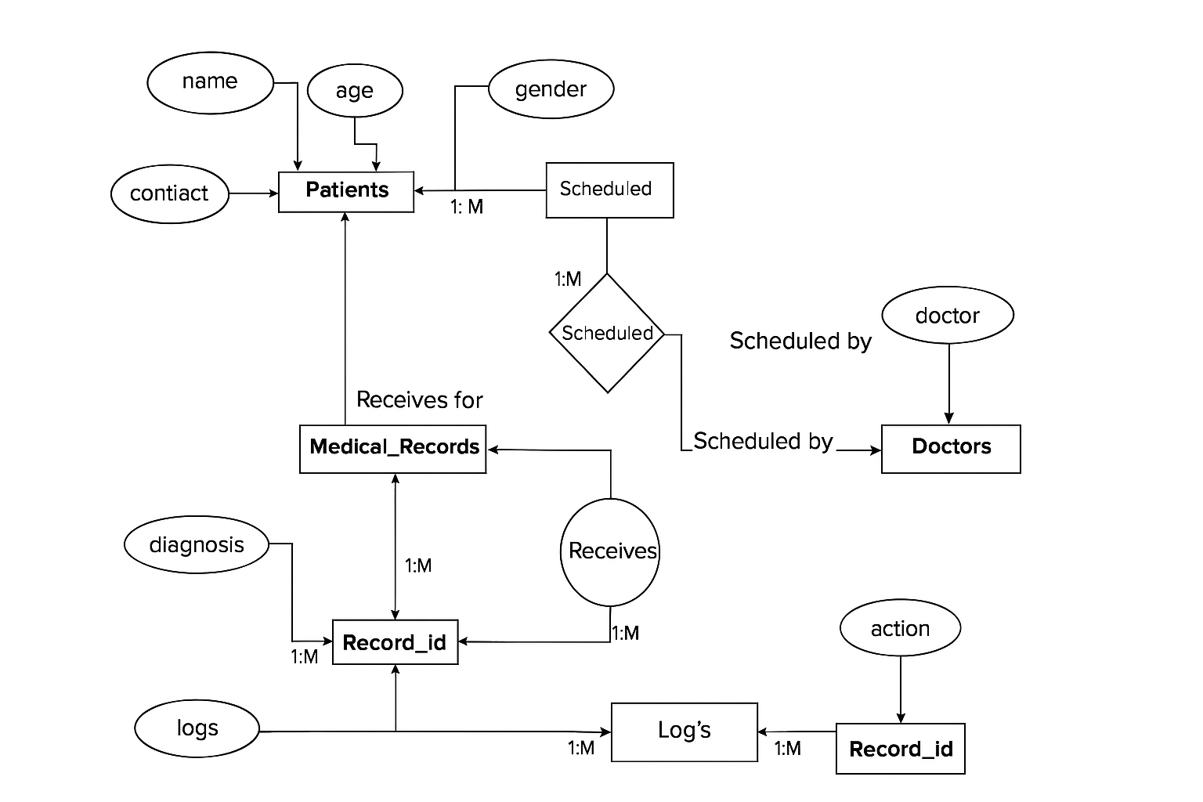

3.4 List of Entities and Attributes
- Patient: patient_id (PK), name, age, gender, contact.
- Doctor: doctor_id (PK), name, specialization.
- Appointment: appointment_id (PK), patient_id (FK → Patient.patient_id), doctor_id (FK → Doctor.doctor_id), appointment_date, status.
- Medical_Record: record_id (PK), patient_id (FK → Patient.patient_id), diagnosis, treatment, record_date.
- Record_Log: log_id (PK), record_id (FK → Medical_Record.record_id), log_time, action.
CHAPTER 3
SYSTEM DESIGN
The Health Care Management System is designed using a three-tier architecture that separates the application into the frontend, backend, and database layers for better scalability, maintainability, and modularity.

Architecture Overview:
- Frontend Layer (Presentation Layer):
Developed using HTML, CSS, and JavaScript, this layer provides the graphical user interface (GUI) through which users interact with the system. It allows users to add, view, and delete patients, doctors, and appointments.
- Backend Layer (Application Layer):
Built using Node.js and Express.js, this layer handles the application logic and routes API requests. It connects the frontend with the database, manages CRUD operations, and ensures proper data flow between components.
- Database Layer (Data Layer):
Implemented using MySQL, this layer stores and organizes all data such as patient details, doctor information, and appointment records. It uses foreign keys, triggers, and stored procedures to maintain data integrity and automate operations.

Data Flow:
- The user interacts with the frontend to perform an action (e.g., add a patient).
- The frontend sends a request to the backend API via HTTP (using Fetch or Axios).
- The backend processes the request, performs the operation (like inserting data), and communicates with the MySQL database.
- The database executes the query and sends the result back to the backend.
- The backend sends the response to the frontend, which updates the UI accordingly.

System Modules:
- Patient Module: Handles patient registration, updates, and deletion.
- Doctor Module: Manages doctor details including specialization and contact information.
- Appointment Module: Manages scheduling, updating, and cancellation of appointments between patients and doctors.
- Medical Records Module: Maintains health records and treatments for each patient.

Database Design:
- patients(patient_id, name, age, gender, contact)
- doctors(doctor_id, name, specialization, contact)
- appointments(appointment_id, patient_id, doctor_id, appointment_date, status)
- medical_records(record_id, patient_id, diagnosis, treatment, record_date)
- record_log(log_id, record_id, log_time, action)

Chapter 4
System Implementation

The implementation of the Health Care Management System involves creating a structured database in MySQL to manage patients, doctors, appointments, and medical records efficiently. The system follows a modular approach, enabling easy management and scalability.
- Frontend Implementation
- The frontend was developed using HTML, CSS, and JavaScript to provide an interactive and user-friendly interface.
- The interface allows users to perform CRUD (Create, Read, Update, Delete) operations on patients, doctors, and appointments.
- Fetch API is used to send asynchronous HTTP requests to the backend, enabling smooth data updates without page reloads.
- Each section (Patients, Doctors, Appointments) has dedicated forms and tables for displaying and managing records.
2.Backend Implementation
The backend was developed using Node.js with the Express.js framework to handle routing and API requests.
It serves as a bridge between the frontend and the database.
Restful APIs were implemented for each module:
- /api/patients → Handles patient management.
- /api/doctors → Manages doctor information.
- /api/appointments → Controls appointment creation and up
- Each route performs SQL operations such as INSERT, UPDATE, DELETE, and SELECT using the MySQL connection.

3.Testing

After integration, all functionalities were tested using Postman and manual testing:
- API endpoints were tested to ensure correct responses.
- Database validations ensured data integrity.
- The user interface was verified for responsiveness and usability.

4.Database Implementation
- The database was implemented using MySQL.
- Tables were created to store information about patients, doctors, and appointments.
- Primary and foreign keys maintain relationships between tables.
- Example tables:
- patients(patient_id, name, age, gender, contact)
- doctors(doctor_id, name, specialization, contact)
- appointments(appointment_id, patient_id, doctor_id, appointment_date, status)

5.Integration
- Once all modules were developed, the frontend, backend, and database were integrated:
- The backend runs on localhost:5000.
- The frontend connects to the backend through API endpoints using HTTP requests.
- Data entered through the frontend is stored in the database and retrieved dynamically.

Create Database
CREATE DATABASE health_care; USE health_care;

Create Tables
CREATE TABLE patients (
patient_id INT AUTO_INCREMENT PRIMARY KEY, name VARCHAR(255) NOT NULL,
age INT NOT NULL,
gender VARCHAR(10) NOT NULL,
contact VARCHAR(15)
);

CREATE TABLE doctors (
doctor_id INT AUTO_INCREMENT PRIMARY KEY, name VARCHAR(255) NOT NULL,
specialization VARCHAR(100) NOT NULL
);

CREATE TABLE appointments (
appointment_id INT AUTO_INCREMENT PRIMARY KEY, patient_id INT NOT NULL,
doctor_id INT NOT NULL, appointment_date DATE NOT NULL, status VARCHAR(20),
FOREIGN KEY (patient_id) REFERENCES patients(patient_id), FOREIGN KEY (doctor_id) REFERENCES doctors(doctor_id)
);
TRIGGER Example

DELIMITER $$

CREATE TRIGGER log_new_record AFTER INSERT ON medical_records FOR EACH ROW
BEGIN
INSERT INTO record_log (record_id, log_time, action)
VALUES (NEW.record_id, NOW(), 'New record added'); -- TRIGGER: logs insert END$$

DELIMITER ;

CRUD Operations
CREATE (Insert a new patient)
INSERT INTO patients (name, age, gender, contact) VALUES ('Rohit Sharma', 34, 'M', '9876543210'),
('Anjali Verma', 29, 'F', '8765432109'),
('Vivek Kumar', 42, 'M', '9988776655'),
('Priya Singh', 38, 'F', '9123456780'),
('Salman Khan', 50, 'M', '8555666777');
Insert at least 5 records into doctors
INSERT INTO doctors (name, specialization) VALUES ('Dr. Suresh Mehta', 'Cardiology'),
('Dr. Pooja Rao', 'Gynecology'), ('Dr. Aakash Jain', 'Orthopedics'),
('Dr. Neha Mishra', 'General Medicine'), ('Dr. Aman Gupta', 'Dermatology');
Insert at least 5 records into appointments
INSERT INTO appointments (patient_id, doctor_id, appointment_date, status) VALUES (1, 2, '2025-10-28', 'Scheduled'),
(2, 1, '2025-10-30', 'Scheduled'),
(3, 4, '2025-09-15', 'Completed'),
(4, 3, '2025-08-22', 'Cancelled'),
(5, 5, '2025-07-12', 'Scheduled');
Insert at least 5 records into medical_records
INSERT INTO medical_records (patient_id, diagnosis, treatment, record_date) VALUES (1, 'Hypertension', 'Medication prescribed', '2025-09-05'),
(2, 'Flu', 'Rest and fluids', '2025-10-01'),
(3, 'Back Pain', 'Physical therapy', '2025-09-16'),
(4, 'Migraine', 'Painkillers and rest', '2025-08-22'),

(5, 'Skin Rash', 'Topical ointment', '2025-07-12');
READ (Fetch patient's medical history)
SELECT * FROM medical_records WHERE patient_id = 1; -- CRUD: READ
UPDATE (Change an appointment status)
UPDATE appointments SET status = 'Completed' WHERE appointment_id = 1; -- CRUD: UPDATE
DELETE (Remove a patient)
DELETE FROM patients WHERE patient_id = 1; -- CRUD: DELETE
CURSOR Example

DELIMITER $$
CREATE PROCEDURE notify_overdue_appointments() BEGIN
DECLARE done INT DEFAULT FALSE; DECLARE pid INT;
DECLARE adate DATE;
DECLARE overdue_cursor CURSOR FOR
SELECT patient_id, appointment_date FROM appointments WHERE status = 'Scheduled' AND appointment_date < CURDATE();
DECLARE CONTINUE HANDLER FOR NOT FOUND SET done = TRUE;
OPEN overdue_cursor; read_loop: LOOP
FETCH overdue_cursor INTO pid, adate; IF done THEN
LEAVE read_loop;
END IF;
INSERT INTO record_log (record_id, log_time, action)
VALUES (pid, NOW(), CONCAT('Appointment overdue on ', adate)); -- CURSOR action END LOOP;
CLOSE overdue_cur
END$$
DELIMITER ;
-- To run the procedure:
CALL notify_overdue_appointments();

CHAPTER 5
RESULTS

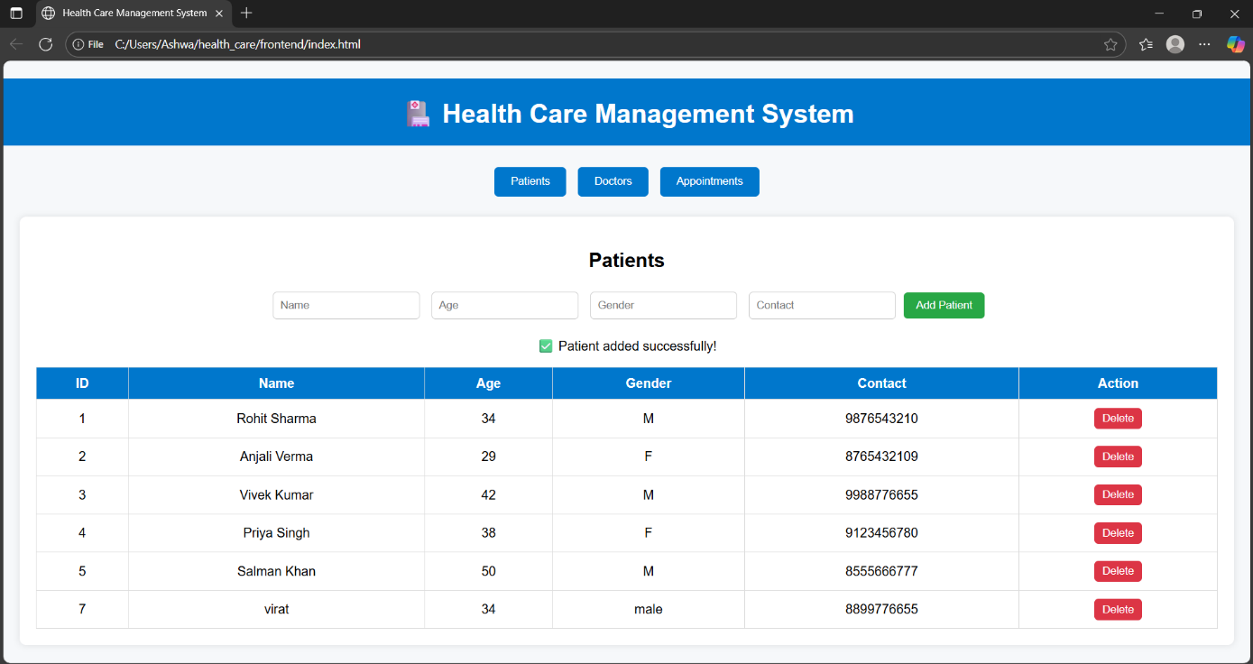
Fig 5.1 Patient adding

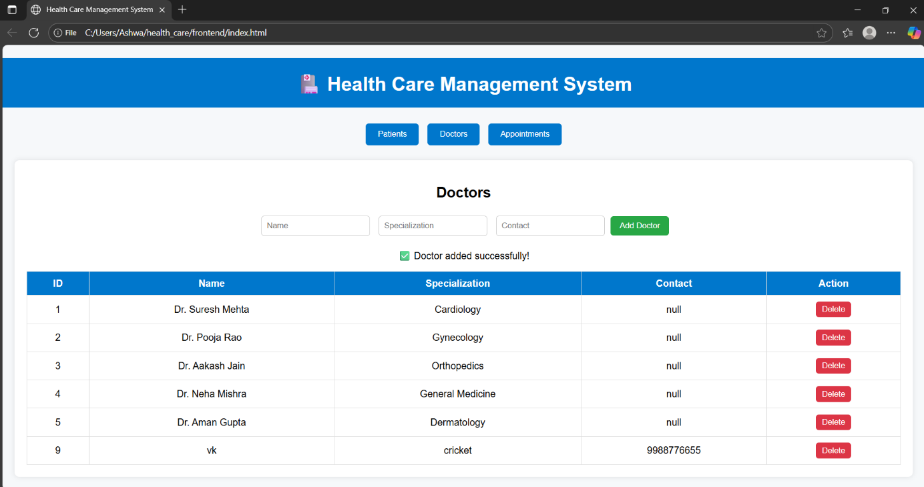
Fig 5.2 Doctor adding

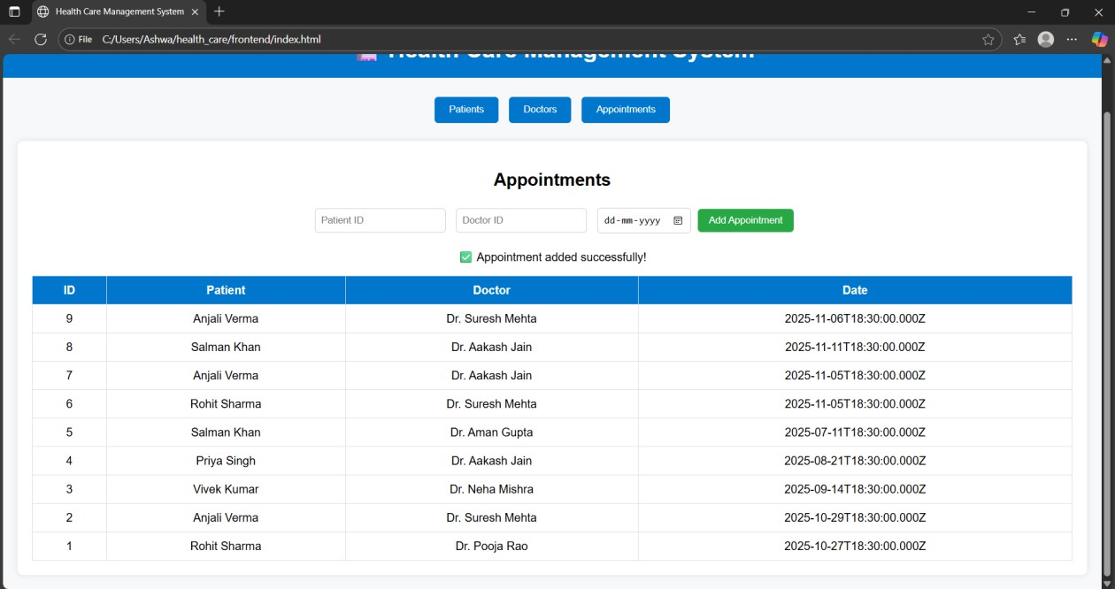

Fig 5.2 Appointment adding

CONCLUSION AND FUTURE ENHANCEMENTS

Conclusion
The Health Care Management System successfully simplifies and automates the process of managing patients, doctors, and appointments in a healthcare setup. By integrating frontend, backend, and database technologies, the system provides an efficient and user-friendly platform for maintaining health records digitally. It eliminates manual paperwork, reduces human error, and enhances data accessibility and accuracy. The project demonstrates how web-based technologies can be effectively used to improve healthcare administration and data management.

Future Enhancements
Although the current system efficiently manages essential healthcare operations, several improvements can be introduced in future versions:
- User Authentication: Add login and role-based access control for admin, doctors, and patients.
- Appointment Notifications: Integrate SMS or email alerts to notify patients about appointments.
- Billing System: Include automated billing and invoice generation for patient visits.
- Search and Filter Options: Enhance usability with advanced search and sorting features.
- Cloud Integration: Store data securely on cloud databases for scalability and remote access.
- Analytics Dashboard: Add data visualization to track hospital performance and patient trends.
- Responsive Mobile App: Develop a mobile version for easier access and management.

REFERENCE

  - Silberschatz, A., Korth, H. F., & Sudarshan, S. — Database System Concepts, 7th Edition, McGraw-Hill Education, 2020.
  - Pressman, R. S. — Software Engineering: A Practitioner’s Approach, 8th Edition, McGraw-Hill Education, 2014.
  - Node.js Documentation — https://nodejs.org/en/docs
  - Express.js Official Guide — https://expressjs.com/
  - MySQL Reference Manual — https://dev.mysql.com/doc/
  - MDN Web Docs — JavaScript, HTML, and CSS Tutorials — https://developer.mozilla.org/
  - W3Schools — Web Development Tutorials — https://www.w3schools.com/

